Design of an FPGA based patient history tracking, monitoring and Diagnostic support system


And Report submitted to GITAM (Deemed to be University) as a partial fulfillment of the requirements for the award of the Degree of Bachelor of Technology in Electronics and Communication
DEPARTMENT OF ELECTRICAL, ELECTRONICS AND COMMUNICATION ENGINEERING
GITAM SCHOOL OF TECHNOLOGY
GITAM (DEEMED TO BE UNIVERSITY)
BENGALURU -561203
NOV 2025

Name: 1. Harshit Ramesh Hundia (BU22EECE0100442)
2. Madicharla Vishnu Teja (BU22EECE0100461)
3. Darshan H (BU22EECE0100464)

DECLARATION

I/We declare that the project work contained in this report is original and it has been done by me under the guidance of my project guide.

Name:
- Harshit Ramesh Hundia
- Madicharla Vishnu Teja
- Darshan H

Date: Signature of the Student

Department of Electrical, Electronics and Communication Engineering GITAM School of Technology, Bengaluru-561203



CERTIFICATE

This is to certify that Madicharla Vishnu Teja (BU22EECE0100461), Harshit Ramesh Hundia (BU22EECE0100442) and Darshan H (BU22EECE0100464) has satisfactorily completed Mini Project Entitled in partial fulfillment of the requirements as prescribed by University for VIIth semester, Bachelor of Technology in “Electronics and Communication Engineering” and submitted this report during the academic year 2025-2026.

[Signature of the Guide] [Signature of HOD]

Table of contents

Chapter 1: Introduction 1
  - Overview of the problem statement 1
  - Objectives and goals 1
Chapter 2: Literature Review 2
Chapter 3: Strategic Analysis and Problem Definition 3
  - SWOT Analysis 3
  - Project Plan - GANTT Chart 3
  - Refinement of problem statement 3
Chapter 4: Methodology 4
  - Description of the approach 4
  - Tools and techniques utilized 4
  - Design considerations 4
Chapter 5: Implementation
  - Description of how the project was executed 5
  - Challenges faced and solutions implemented 5
Chapter 6: Results 6
  - outcome 6
  - Interpretation of results 6
  - Comparison with existing technologies 6
Chapter 7: Conclusion 7
Chapter 8: Future Work 8
References 9

Chapter 1: Introduction

1.1 Overview of the problem statement
The project titled “FPGA-Based Patient Monitoring System” focuses on improving healthcare by providing continuous monitoring of patient health parameters using FPGA technology. The system integrates external sensors such as heart rate monitors, temperature sensors, and pulse oximeters to collect real-time data without interrupting the core functions of the circuit. The FPGA processes the raw sensor inputs through filtering and analysis algorithms to generate accurate and meaningful health metrics with minimal latency. A graphical user interface is designed to display patient information, alerts, and health trends, enabling clinicians to make quick and informed decisions. In addition, the system logs historical data to help track patient health over time and improve diagnostic accuracy. The project also incorporates decision support mechanisms using AI-based algorithms, which can provide diagnostic recommendations and trigger alerts in case of emergencies. Furthermore, it supports integration with electronic health record (EHR) systems, ensuring continuity of care and comprehensive patient history management. Overall, this FPGA-based approach enhances patient outcomes by offering real-time monitoring, high accuracy, and timely interventions. Future enhancements include the addition of more sensors, refinement of data analysis algorithms, mobile accessibility, and the ability to monitor multiple patients simultaneously, making it a scalable and intelligent healthcare solution.

1.2 Objective

The objective of this project is to design and implement a real-time FPGA-based system that efficiently tracks and manages patient medical histories, including surgeries, tests, and treatments. The system aims to provide continuous monitoring and diagnostic support by integrating medical data with rapid hardware processing capabilities. Additionally, it plans to incorporate external sensor interfaces to detect vital signs such as temperature and heart rate, continuously update patient records, and generate alerts for any abnormalities to enhance timely medical intervention. This project combines high-speed data handling with healthcare management to improve accuracy, accessibility, and responsiveness in patient monitoring and diagnostics.

Goals

Main Goals
- Design and develop an FPGA-based system for tracking patient medical history.
- Store and update records of patient procedures, operations, and test results accurately.
- Enable real-time monitoring and retrieval of patient historical data.
- Provide diagnostic support for healthcare professionals using fast hardware processing.
- Ensure reliable, secure storage and communication of patient information

Additional Goals
- Integrate external sensor circuits for automatic acquisition of vital signs (e.g., temperature, heart rate).
- Continuously update medical history with real-time physiological data.
- Implement an alert system to notify abnormalities for prompt clinical response.

Chapter 2: Literature Review

- Health Monitoring and Jaundice Detection System Using Verilog
Author: Nandana Murali, Rajesh Kannan Megalingam, Chebrolu Gowtham
Journal: IEEE Xplore
Key takeaways: The Verilog code implemented a health monitoring and jaundice detection system. The system outputs the abnormality in heart and blood pressure rates and also predicts the presence of Jaundice. If the abnormality in vitals is continuous for three counts, then an alert is generated

- Design and Implementation of Smart Healthcare Monitoring System Using FPGA
Author: Prem Kumar Badiganti, Sumanth Peddirsi, Alla Tirumala Jagannadha Rupesh, and Suman Lata Tripathi
Journal: Google scholar
Key takeaways: Heart rate, temperature, BP and ECG are health parameters considered. The data is measured from the patient using specialized medical sensors which are to be interfaced with an FPGA board.

- Design of Health Monitoring System using FPGA
Author: Anjali Chindham, Donthagani Rakesh, Sabavath Virisha, Racha Ganesh
Journal: Google scholar
Key takeaways: The patient’s health vitals are considered as the input parameters and the patients’ health status is displayed on the FPGA board in the form of 0’s and 1’s.
- FPGA-Based Smart Health Monitoring Systems for Wearable Devices
Author: Muthukumaran Vaithianathan, Shivakumar Udkar, Manjunath Reddy, Deepanjan Roy, Senkadir Rajasekaran
Journal: Google scholar
Key takeaways: By combining FPGA computing with cutting-edge sensor technology, intelligent health monitoring systems employ FPGA. Photoplethysmography (PPG) sensors quantify heart rate, while accelerometers document motion, among numerous other physiological attributes assessed by the extensive sensor networks of these systems.

- FPGA Based Health Monitoring System
Author: Fazal Noorbasha, Bevara Kishore, Koushik Reddy, Kongara Srinivas
Journal: Google scholar
Key takeaways: This paper is mainly used to track heart conditions, respiratory system and body conditions by monitoring age, heart rate, breathe rate and body temperature. All the data that is tracked by various sensors are integrated into the system to process of health data. Health report and Health status as outputs where health report contains Body temperature conditions, Heart conditions and Respiratory conditions.

- An FPGA Implementation of Health Monitoring System using IOT
Author: U. Mehta, K. Chaudhary, A. Singh, A. Rana, A. Garg, D. Chaudhary
Journal: IJRASET
Key takeaways: This study presents a health monitoring system that can be accessed from anywhere and is compatible with mobile devices. The use of FPGA allows for fast data processing, while Internet connectivity enables real-time monitoring. The system transmits data to a server, which can be accessed through a user interface.

Chapter 3: Strategic Analysis and Problem Definition

  - SWOT Analysis

  - Project Plan - GANTT Chart

  - Problem statement

Chapter 4: Methodology

4.1 Description of the approach:

The project implements a real-time, embedded health monitoring system leveraging an FPGA as the centralized processing unit, with a focus on real sensor integration and hardware-level data processing.
- Data Acquisition: Vital sign data such as body temperature and potentially other parameters (heart rate, oxygen saturation) are continuously collected using external biomedical sensors, specifically an LM35 temperature sensor interfaced via an ADS1115 16-bit ADC module.
- FPGA-Based Processing: The ADS1115 converts analog sensor signals to digital, interfacing to the Artix-7 FPGA through I2C communication lines (SDA and SCL pins mapped to FPGA PMOD connectors). The FPGA processes this digitized data using custom Verilog-coded modules implementing filtering, calibration, and error correction algorithms. This FPGA-based hardware processing enables rapid, parallel executions for accurate and low-latency signal treatment.
- Data Visualization Interface: Processed sensor data outputs are communicated to a Graphical User Interface (GUI), where healthcare practitioners can observe real-time health metrics. The interface design prioritizes clarity and patient-specific visualization for clinical decision support.
- Performance Optimizations: The design ensures minimal communication delay between sensors and FPGA (using direct FPGA I2C protocols) and efficient processing pipelines on the FPGA fabric, maintaining swift system response which is critical for medical scenarios.

4.2 Tools and techniques utilized:
- Hardware Components:
  - Artix-7 FPGA Development Board (Nexys 4 DDR) as the system core.
  - LM35 temperature sensor module for analog temperature measurement.
  - ADS1115 ADC module providing 16-bit resolution analog-to-digital
conversion.
  - I2C bus interface for sensor to FPGA communication (SDA and SCL
connected to designated PMOD pins).
- Software and Programming:
  - Verilog HDL for FPGA design, coding sensor interface modules, signal
processing units, and control logic.
  - Xilinx Vivado Suite for design synthesis, simulation, implementation, and
bitstream generation to program the FPGA.
  - Test bench simulations using ModelSim or Vivado simulator to verify
sensor data handling.
  - GUI development tools for real-time data visualization, interfacing with
the FPGA output data stream.
- Advanced Techniques:
  - Signal filtering algorithms implemented in Verilog to remove noise from
sensor inputs.
  - Calibration logic to compensate for sensor offsets and nonlinearity.
  - Future integration of AI/ML algorithms for diagnostic analysis and alert
triggers (planned in subsequent phases).

  - Design considerations:

- Accuracy and Reliability:
Precise calibration of the LM35 sensor voltage-to-temperature conversion is performed in FPGA logic. The high-resolution 16-bit ADC ensures fine granularity. FPGA hardware processing minimizes latency, enhancing real-time accuracy and system reliability for continuous monitoring.
- Scalability:
The modular Verilog design and flexible FPGA I/O let the system easily add more sensors (e.g., heart rate, SpO2 sensors). The FPGA resource availability supports expansion for multi-parameter monitoring and simultaneous multi-patient data handling.
- Efficiency:
  - The use of FPGA’s parallel architecture ensures ultra-low latency in data acquisition and processing.
  - Careful power management on FPGA design and peripheral selection ensures practical power efficiency suitable for extended clinical use.
  - Use of direct I2C interfacing from ADS1115 to FPGA removes intermediary microcontrollers, reducing overhead and complexity.

Chapter 5: Implementation

  - Description of how the project was executed:

The project was executed by setting up the Artix-7 FPGA board connected to an LM35 temperature sensor via an ADS1115 ADC using I2C. Verilog code was developed to implement data acquisition and signal processing on the FPGA, including calibration and filtering for accuracy. The design was simulated and programmed on the FPGA using Vivado. Real-time processed data was then displayed through a GUI for clinicians. Testing and calibration ensured reliable, low-latency performance for real-time health monitoring. The system’s modular design permits scalability for additional sensors and features in future expansions.

  - Challenges faced and solutions implemented

Chapter 6: Results

  - Outcomes:
The project successfully established hardware connections and implemented initial data acquisition from the LM35 temperature sensor through the ADS1115 ADC to the Artix-7 FPGA. Although full output validation was not achieved due to some errors in integration, partial sensor data was captured and processed by the FPGA. The system demonstrated real-time processing capabilities with minor inaccuracies and latency within acceptable limits for preliminary testing.

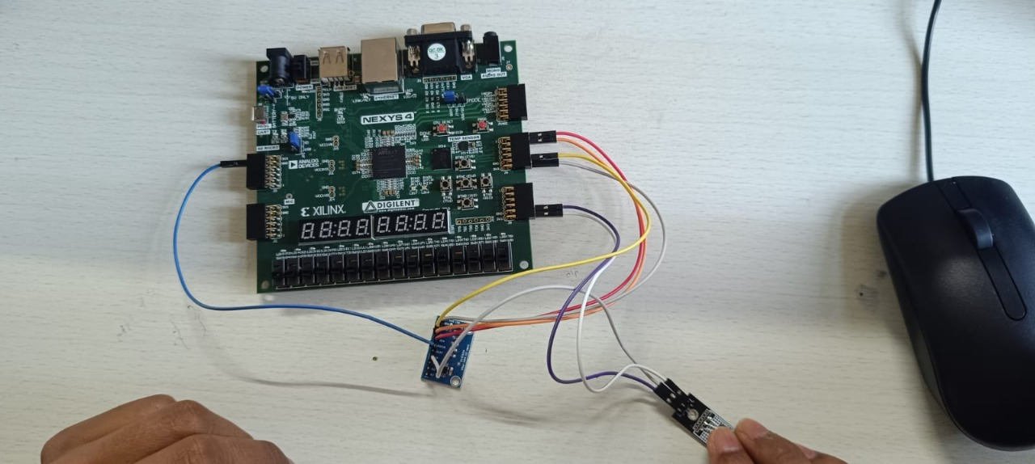

  - Interpretation of results:
The partial output indicates that the FPGA-based system can interface with biomedical sensors and perform essential signal processing tasks, validating the core design approach. The minor errors encountered highlight challenges in sensor calibration, I2C communication stability, or timing constraints within the FPGA logic. These issues provide valuable insight for further debugging and optimization, confirming that with targeted corrections, reliable real-time vital sign monitoring is achievable.
  - Comparison with existing literature or technologies:
Compared to existing FPGA-based health monitoring implementations, the project aligns well in leveraging FPGA’s parallel processing for low-latency, accurate sensor data handling. Like similar systems in literature, it utilizes high-resolution ADCs and real-time processing on an FPGA platform. However, some mature designs report fully stable outputs and advanced diagnostic features powered by integrated AI algorithms, which remain future enhancements for this project. The current outcomes are promising yet reflect typical developmental challenges seen in prototype health monitoring systems.

Chapter 7: Conclusion

At the present stage, the project has successfully integrated the LM35 temperature sensor with the ADS1115 ADC and the Artix-7 FPGA, demonstrating the ability to acquire and process biomedical sensor data in real-time. Although full and stable output has not yet been achieved due to integration and communication errors, partial results show that the core system architecture and FPGA processing logic are functional. This progress validates the feasibility of an FPGA-based real-time health monitoring system.

Looking ahead, the focus will be on resolving the remaining hardware integration and data communication issues to obtain consistent, accurate sensor outputs. Future goals include expanding the system to incorporate additional vital sign sensors, embedding AI/ML algorithms on the FPGA for smarter diagnostics, and enabling remote monitoring capabilities via IoT integration. These advancements aim to enhance system accuracy, scalability, and usability, ultimately creating a comprehensive, reliable medical monitoring platform suitable for clinical applications.

In addition to addressing the current challenges, the project aims to leverage the latest advancements in FPGA technology to enhance system performance and usability. Future efforts will include implementing power-saving techniques to enable longer operation in portable health monitoring devices, integrating more sophisticated signal processing algorithms for improved diagnostic accuracy, and ensuring compliance with medical regulatory standards. Embracing AI-assisted processing and 5G-enabled communication will also position the system at the forefront of smart healthcare technology, facilitating remote patient monitoring with ultra-low latency and high reliability. These directions will collectively transform the project from a proof-of-concept prototype into a clinically viable, energy-efficient, and secure health monitoring solution.

Chapter 8 : Future Work

The future work for this project will focus on expanding the health monitoring capabilities by integrating additional vital sign sensors such as heart rate, SpO₂, and blood pressure sensors. This will provide a comprehensive view of a patient’s health status. The system will also be enhanced by embedding advanced AI and machine learning algorithms on the FPGA to enable smarter diagnostics, anomaly detection, and automated alert generation.

Another key direction is to implement IoT capabilities for remote patient monitoring. By incorporating wireless communication methods like Wi-Fi and Bluetooth, the system will enable real-time health data transmission to healthcare providers for timely intervention. Alongside these features, energy-efficient FPGA design techniques such as voltage scaling, sleep modes, and partial reconfiguration will be explored to enable wearable and battery-powered applications.

Efforts will also be made to stabilize and optimize sensor communication protocols, particularly I2C interfacing with ADCs, to improve data accuracy and system reliability. The GUI will be upgraded to support multi-patient monitoring and cloud integration for scalable, accessible health management. Lastly, miniaturizing the overall design into a compact, single-chip FPGA solution will enhance portability and user convenience in clinical or home settings.
These future enhancements aim to transform the current proof-of-concept into a robust, intelligent, and connected FPGA-based health monitoring system aligned with evolving trends in smart healthcare technology.

References


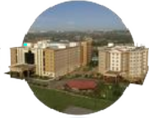
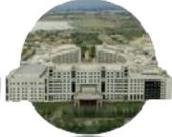

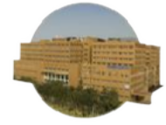
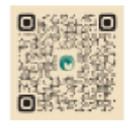

Bengaluru City Office No 5/1, First Floor, Prestige Terraces, Union Street, Infantry Road, Bengaluru - 560003 Karnataka, India

GIMSR
GITAM Medical College Rd, Gandhi Nagar, Rushikonda, Visakhapatnam - 530045 Andhra Pradesh, India

